Labour Market Information/Intelligence (LMI)

Local Employment
London’s economy is growing more than four times as fast than in the country’s poorest regions. Jobs in London are expected to continue to increase for the foreseeable future, with a significant increase in jobs requiring degrees or vocational qualifications and apprenticeships at level 4 or above. In the last two decades growth has been concentrated in Business Services, in other services (Health, Education) and in Retail and Accommodation and Food. Employers based in Hackney have almost doubled since 2010. The three employment sectors with the largest number of businesses are:

Professional, Scientific and Technical e.g. solicitors, accountancy, architectural activities, advertising
Information and Communication e.g. publishing, radio, TV, sound and music production
Arts, Entertainment and Recreation e.g. museums, sports facilities and performing arts

As well as jobs across London, pupils in Hackney schools will have an increasing number of very local career opportunities available to them as regeneration projects take shape. The number and types of jobs based in Hackney and the surrounding areas is predicted to increase dramatically over future decades. Many of the opportunities will require qualifications at level 4 or above so pupils should consider further or higher education, or higher or degree apprenticeships.

The Queen Elizabeth Olympic Park
Developments in the park are already bringing new jobs to the area and it is estimated that up to 40,000 jobs could be available on and around the park by 2025. These include construction jobs during the building phase; high tech jobs based at Here East; public sector and charity jobs at TfL, Unicef and the Financial Conduct Authority in the new International Quarter.

The new East Bank will house the V&A/Smithsonian Institution, Sadler’s Wells, UCL, London College of Fashion, and BBC music studios; providing jobs and study opportunities related to theatre, dance, fashion, music, museums and universities. Westfield Stratford City and developments in Stratford town centre are increasing local office and retail jobs.

Tech City/Silicon Roundabout
The area around Old Street roundabout continues to be where new tech business are launched Google and Amazon also have offices there alongside Zoopla, Asos, Moo, Spotify, Songkick.com, Mind Candy and more.

Changing ways of working
The way most young people work as they develop their careers, is likely to vary from that of their parents.

Portfolio careers
A portfolio career is one with multiple part-time jobs with different employers, that when combined are the equivalent of a full-time position. This can work well if you are trying to move into competitive freelance work, establish your own business, or just pursue a passion. New technologies such as apps can help manage contracts and finances.

Freelance working
Jobs that employ freelancers are increasing, particularly in the creative sector which includes film, TV, music and dance. Changes in technology are also leading to more freelance work in areas such as journalism, coding and data analysis. Young people interested in careers in these sectors need to make themselves aware of how to manage a freelance career. Apps can now help with managing finances and tax and even allow you to find and apply for jobs. Networking, resilience and an ability to ‘sell yourself’ are very useful skills for a freelancer.

Technology
Advances such as Artificial Intelligence (where intelligent machines work and act like humans), Virtual Reality (where the user can interactive with a computer-generated environment) and Blockchain (where information, can be securely and quickly transferred via the internet) are changing the nature of jobs in many sectors.

As well as the rise online shopping the retail industry is also using new technology to improve the in store experience. For example in 2015 Westfield, Stratford used interactive video walls showing the latest fashion trends; gave customers a chance to visit a colourful dreamscape using Oculus Rift virtual reality goggles and use Edit Me, a giant touchscreen, to find outfits in Westfield's retailers.

Repetitive jobs in the legal and finance sectors are already being affected by automisation. People with skills difficult for computers to carry out, such as creativity, empathy and an ability to work in teams or with partners are less likely to find their jobs replaced by technology.

Lifelong careers
While some traditional employment sectors, such as education, the nursing/care sector and construction, will continue to expand, changes in technology and its impact on working methods mean that new jobs and sectors are emerging. A young person who starts a job on leaving school or university is expected to have many different jobs and several careers before they retire. So improving self-awareness of your skills and interests is vital to allow you to take up new opportunities as they emerge.

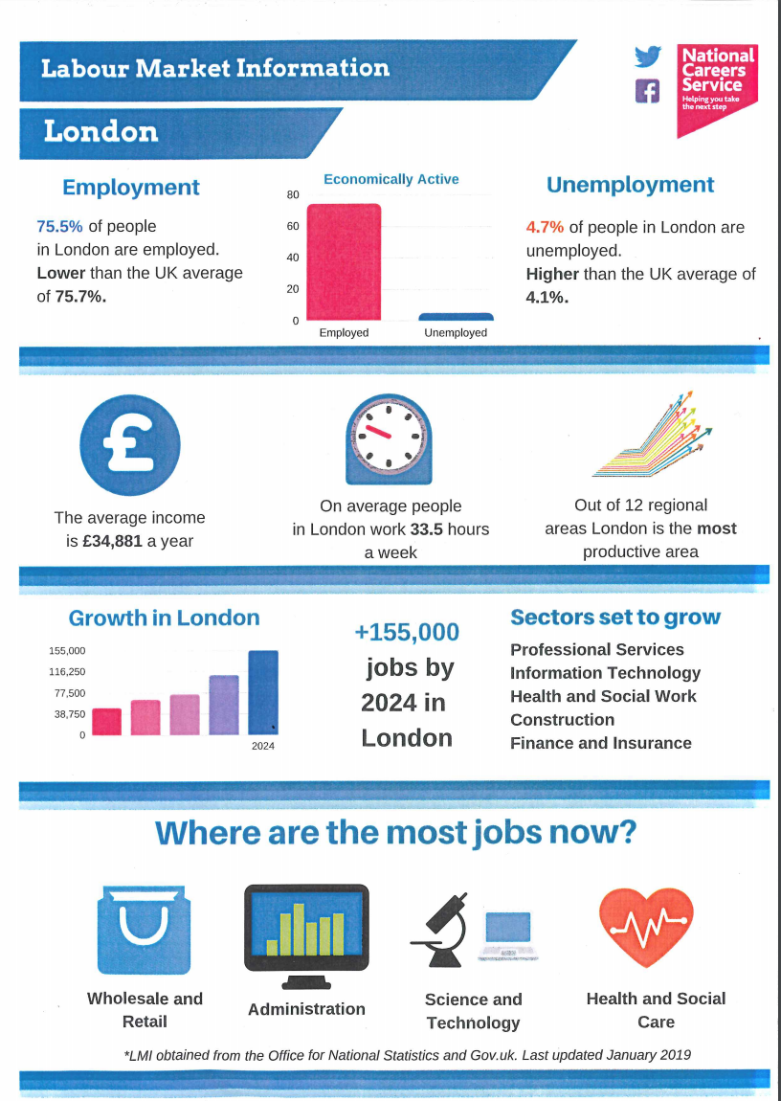

ONS 2017 data
ONS 2015 data

